Screenshots Portfolio Milestone Module 2
Landing Page
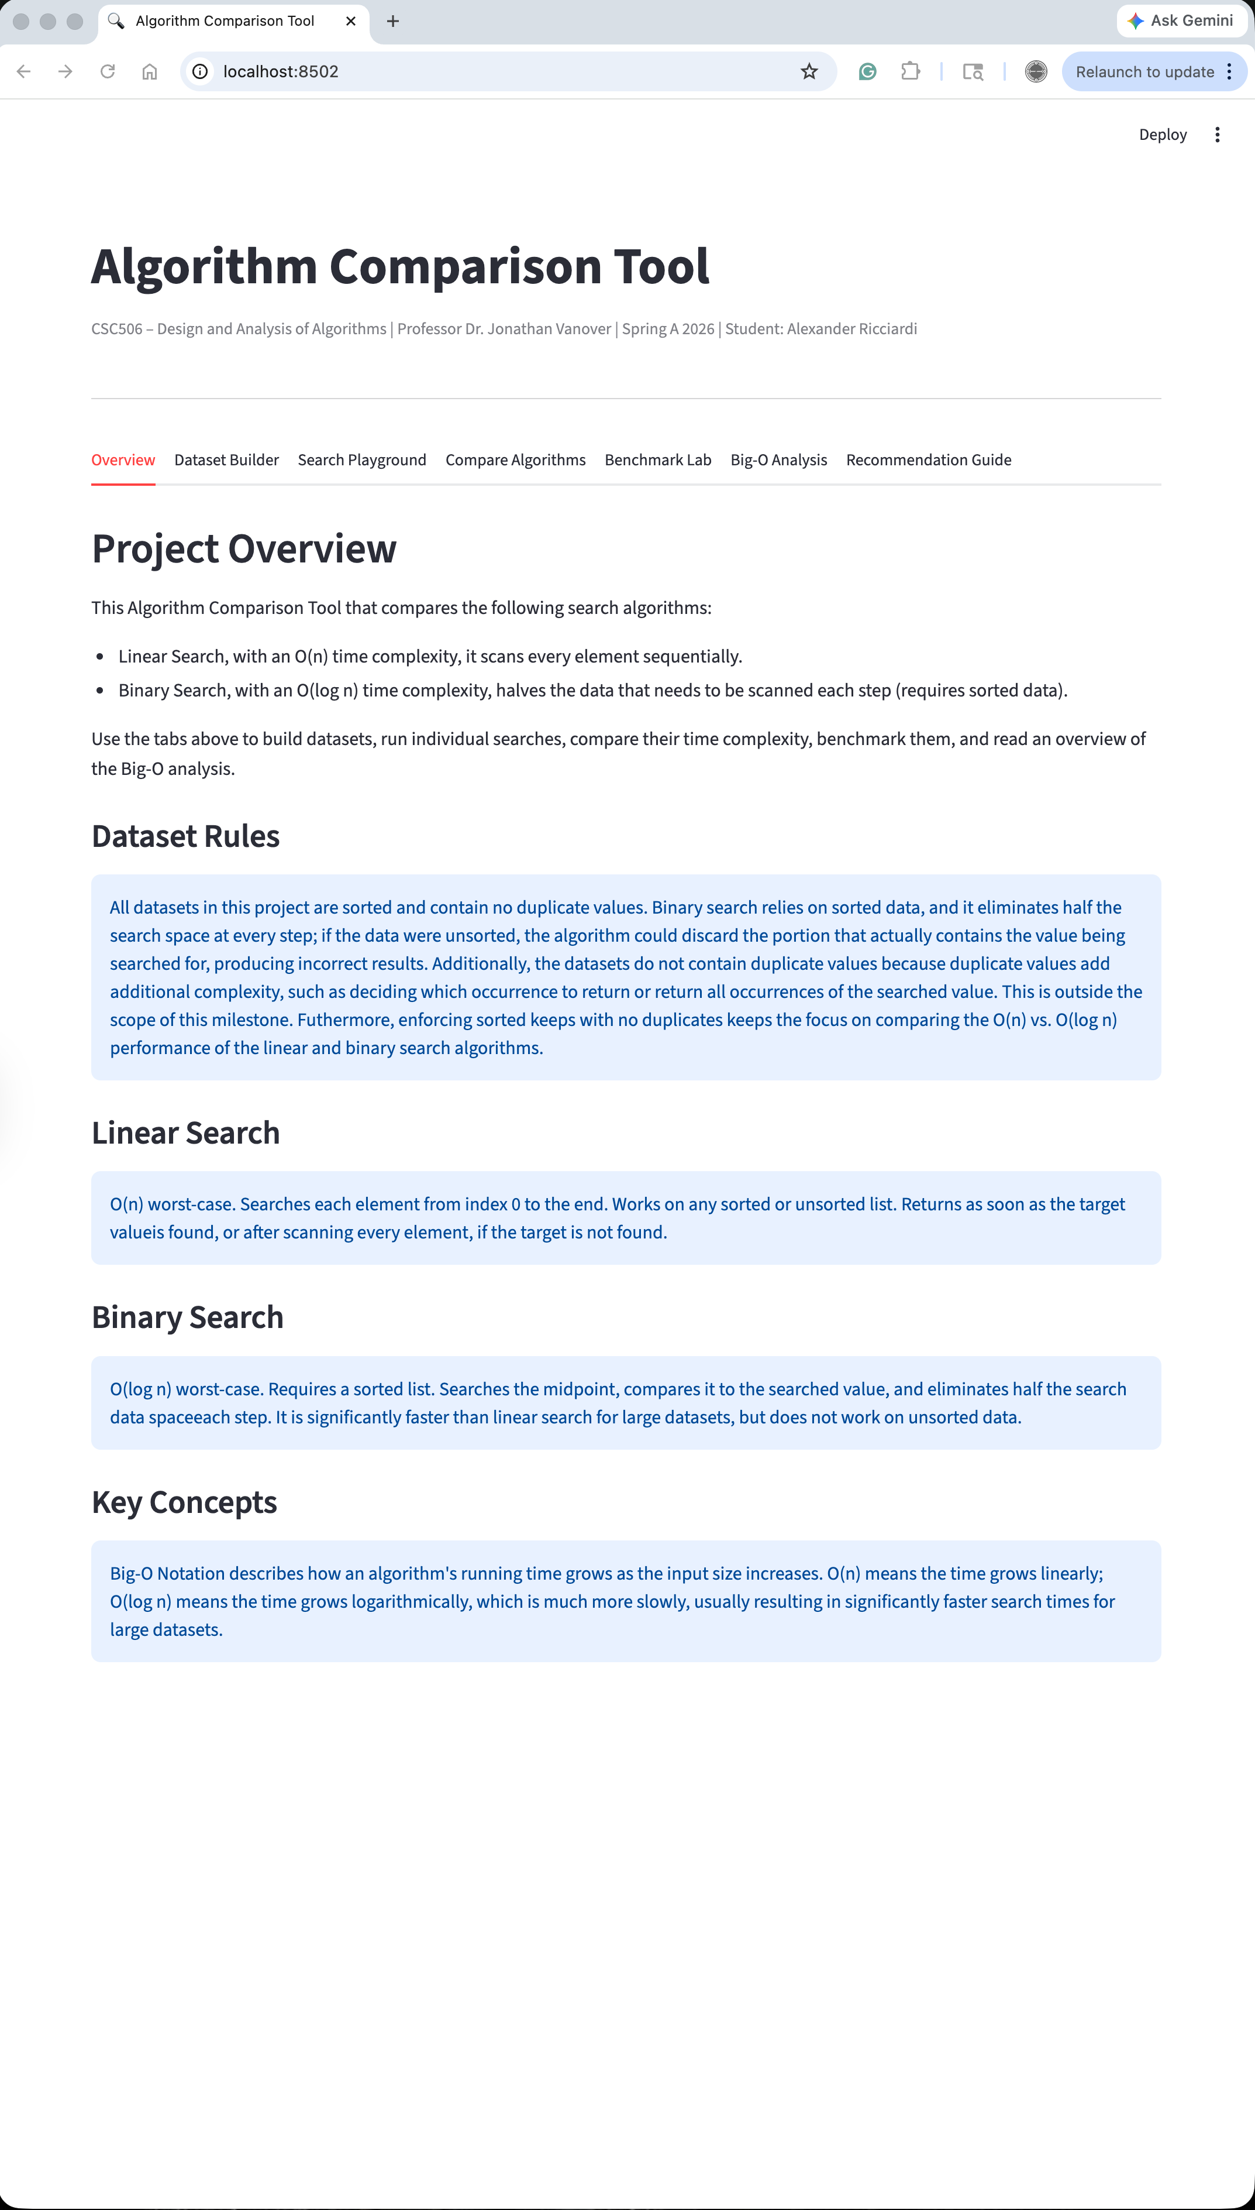
Dataset Builder
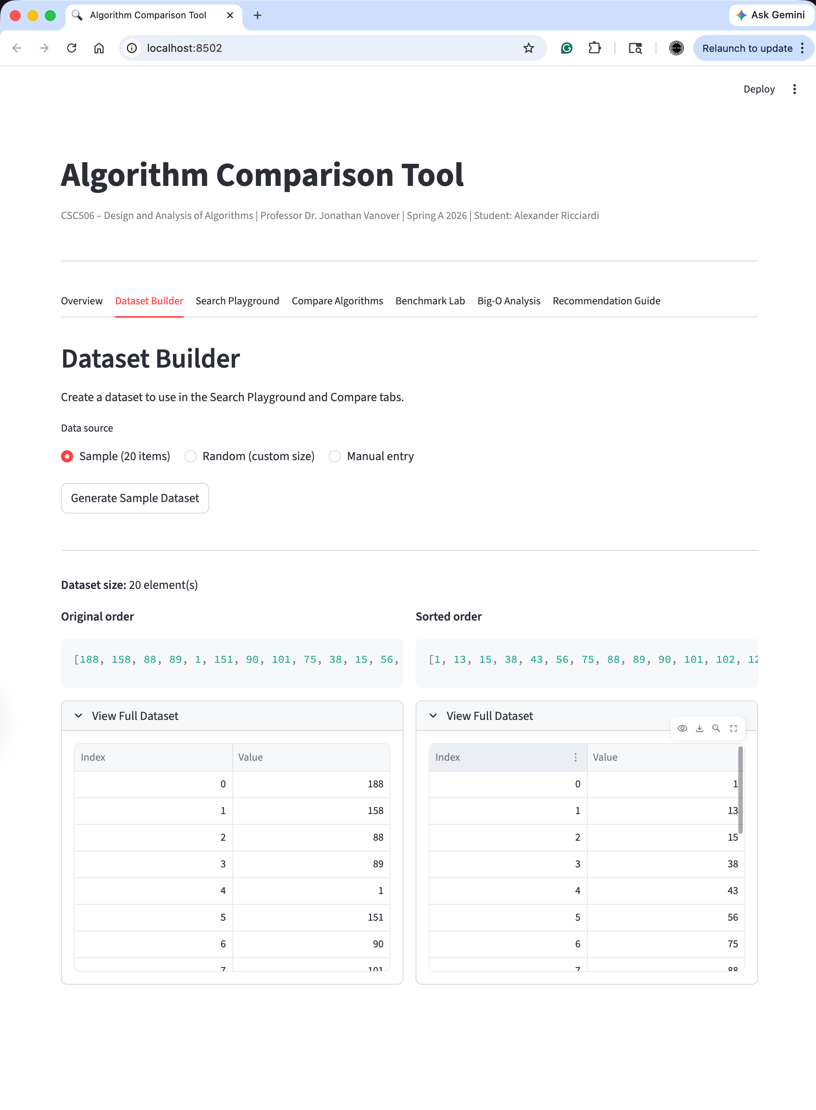
Search Playground (Linear Search)
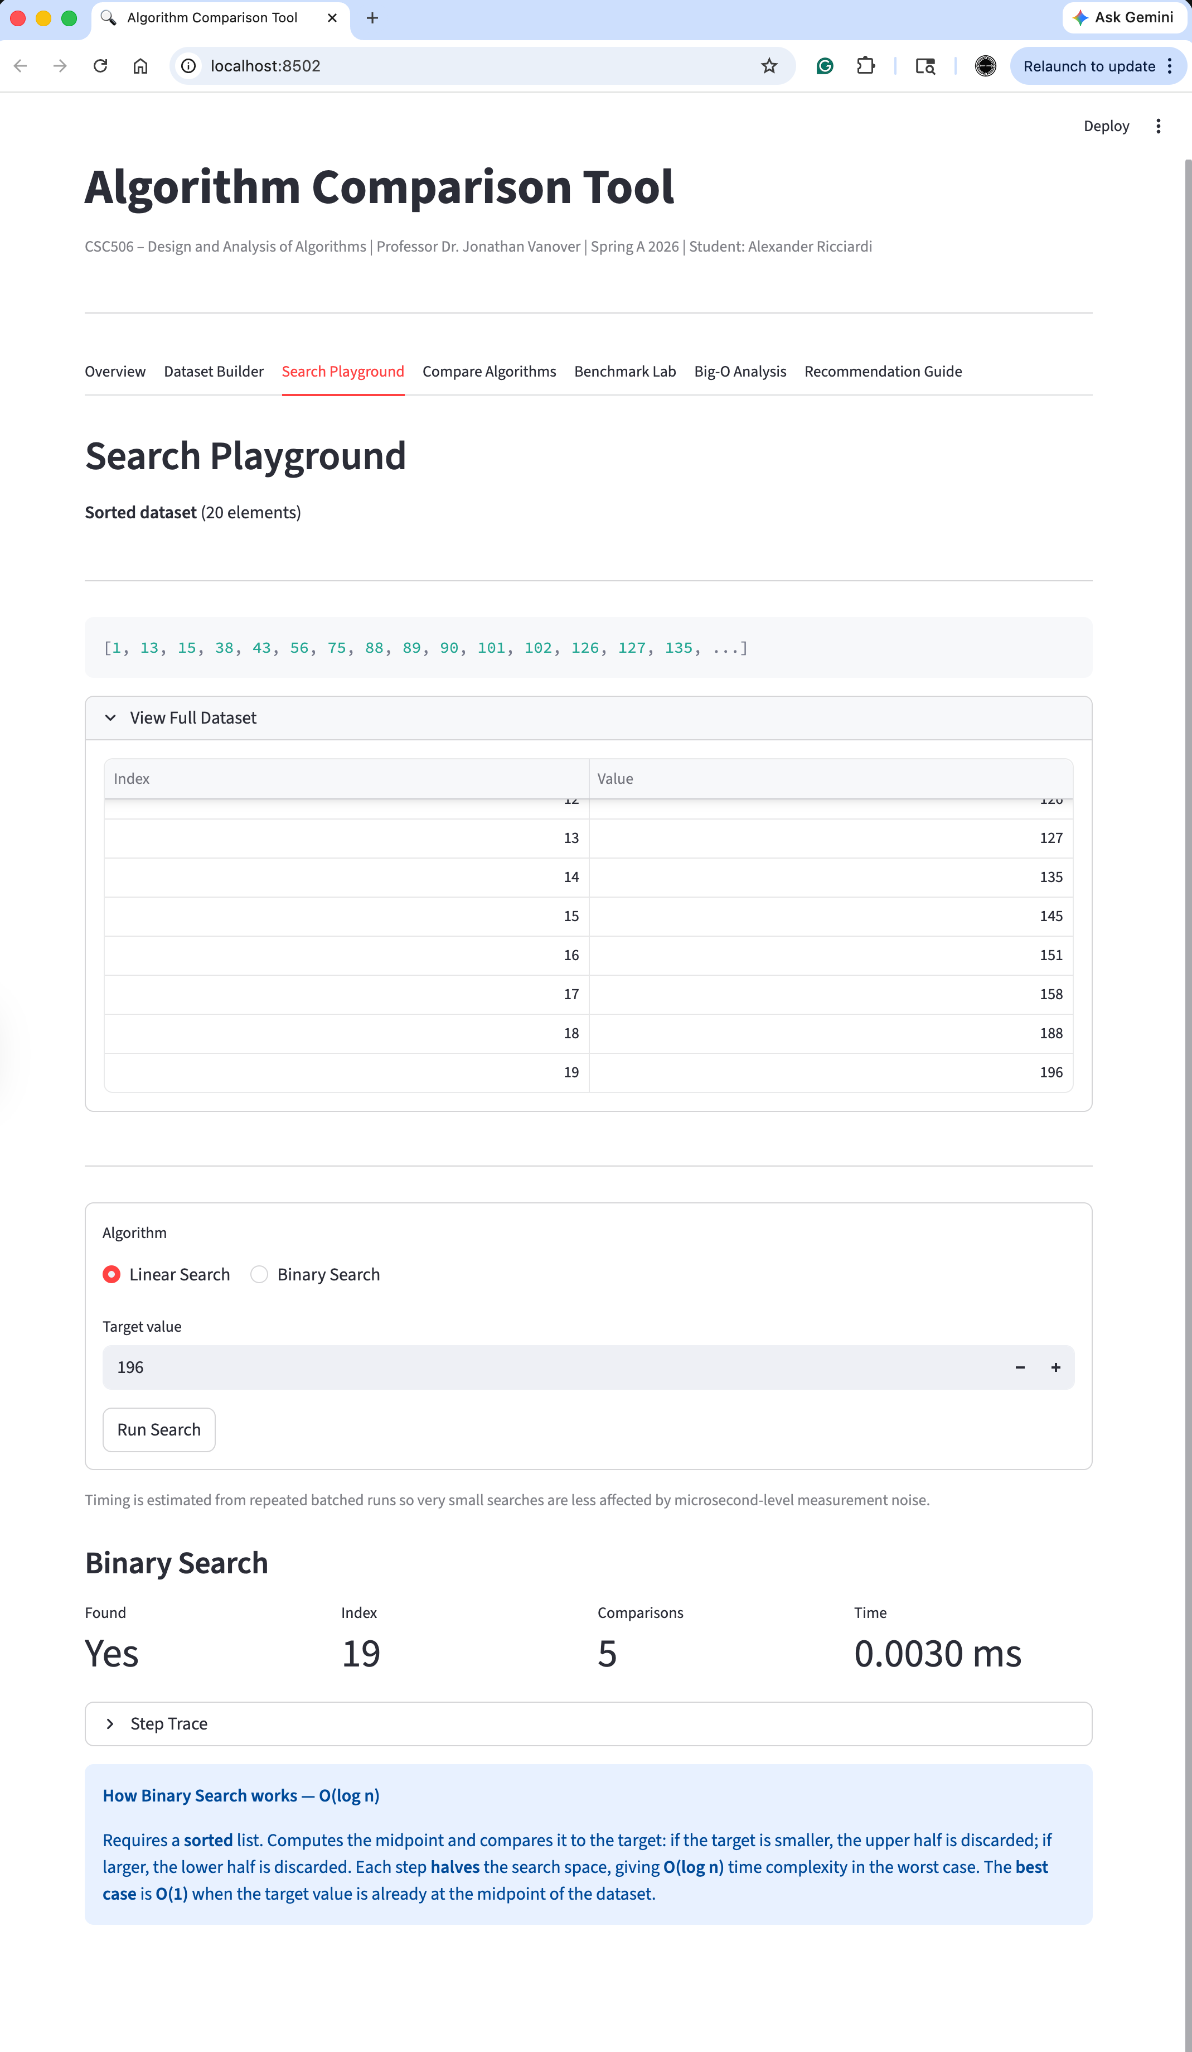
Search Playground (Binary Search)
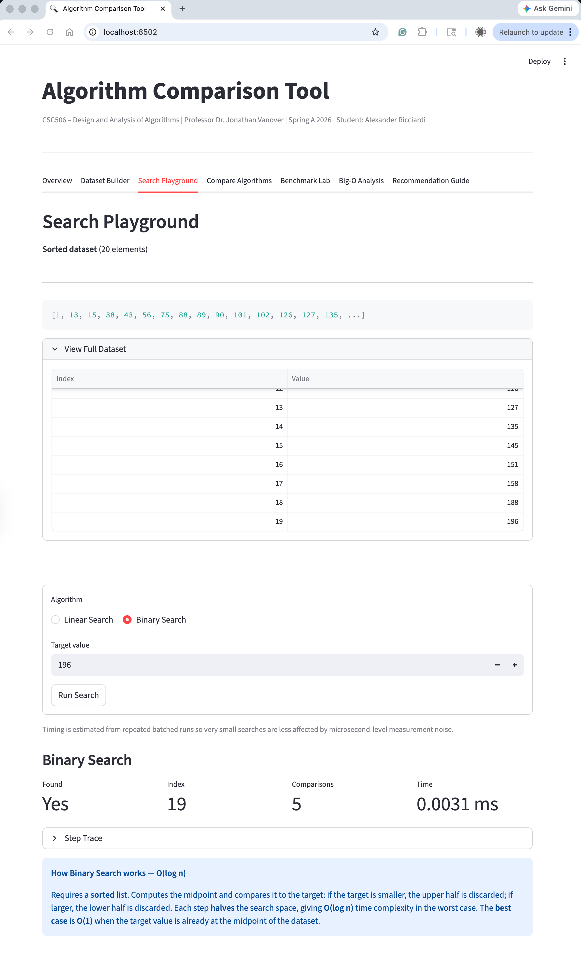
Compare Algorithms
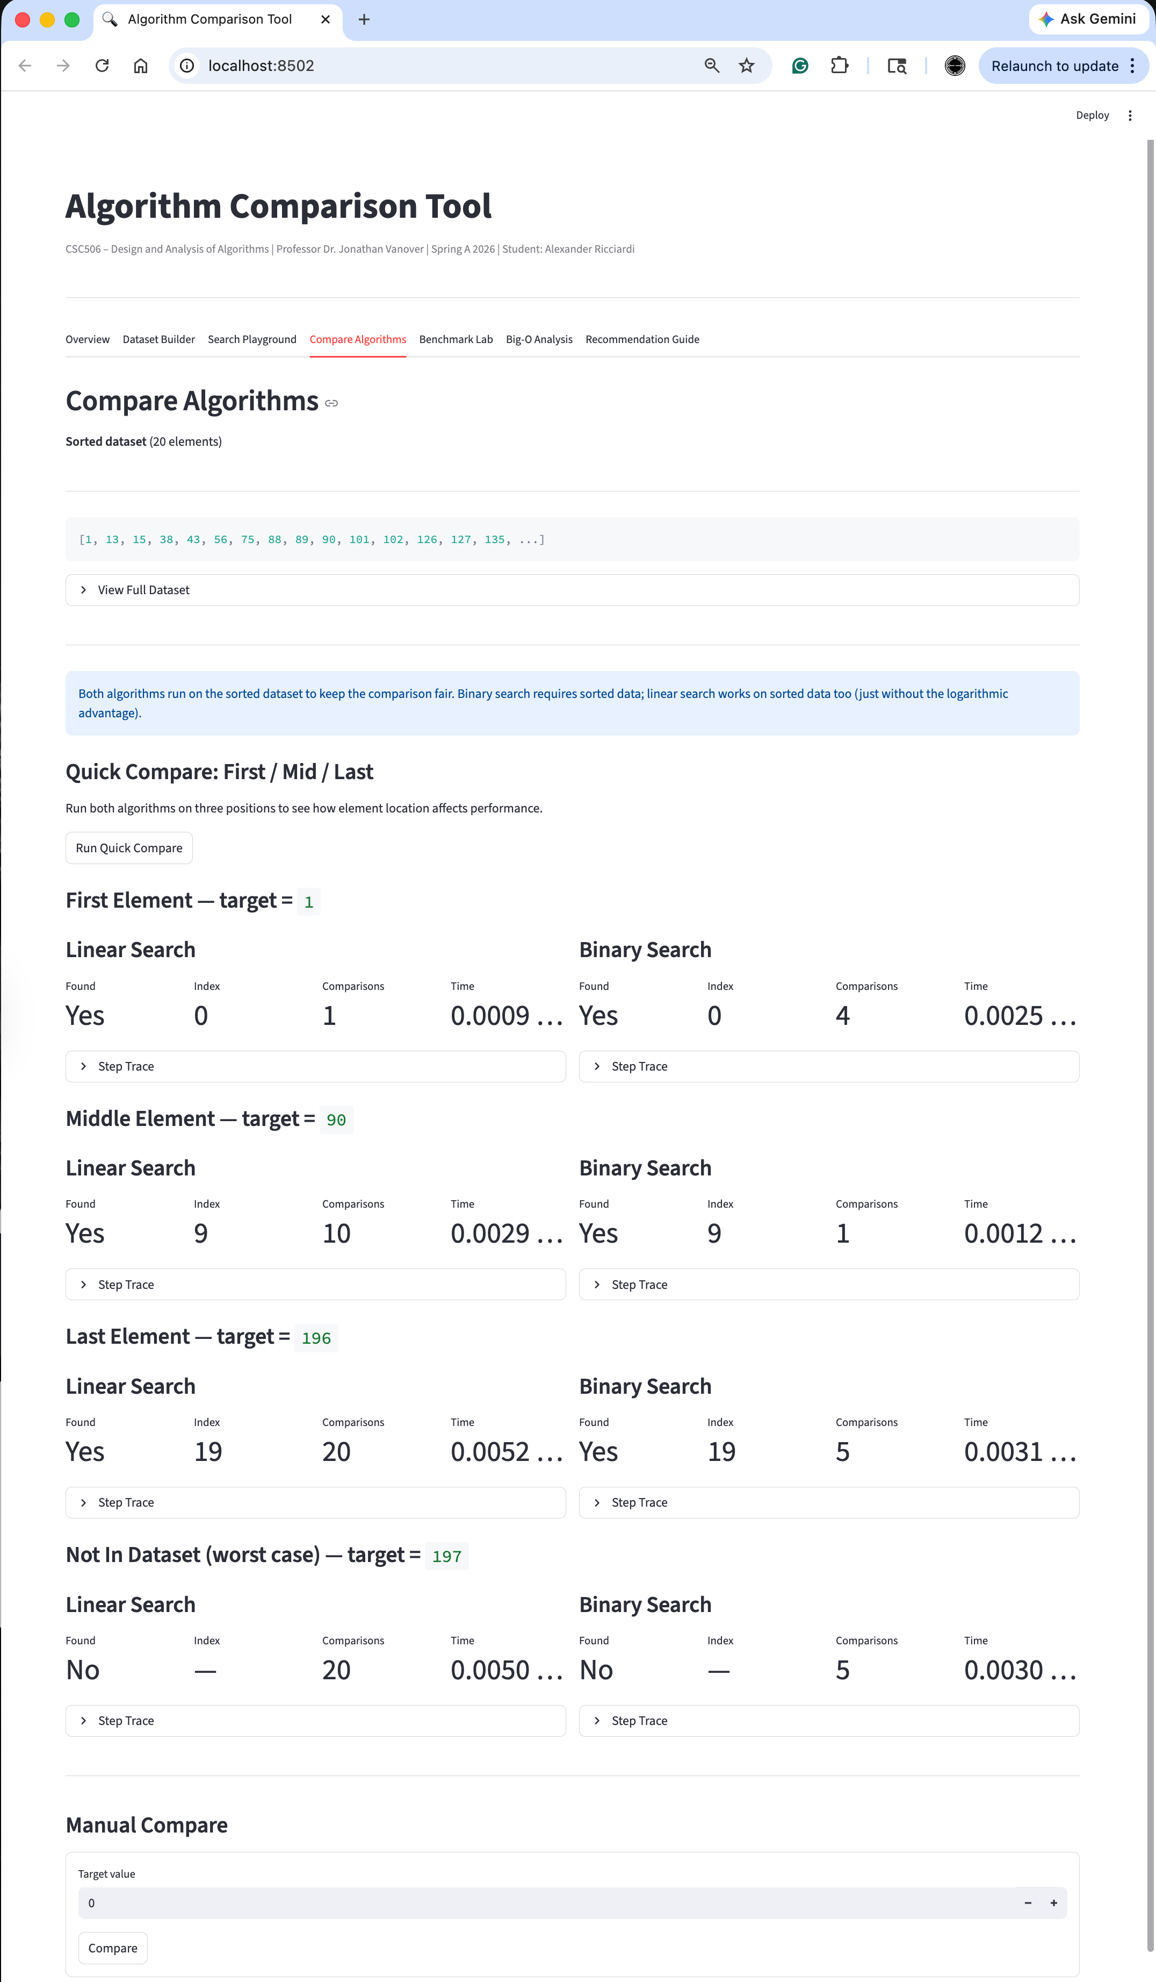
Algorithm Comparison Tool
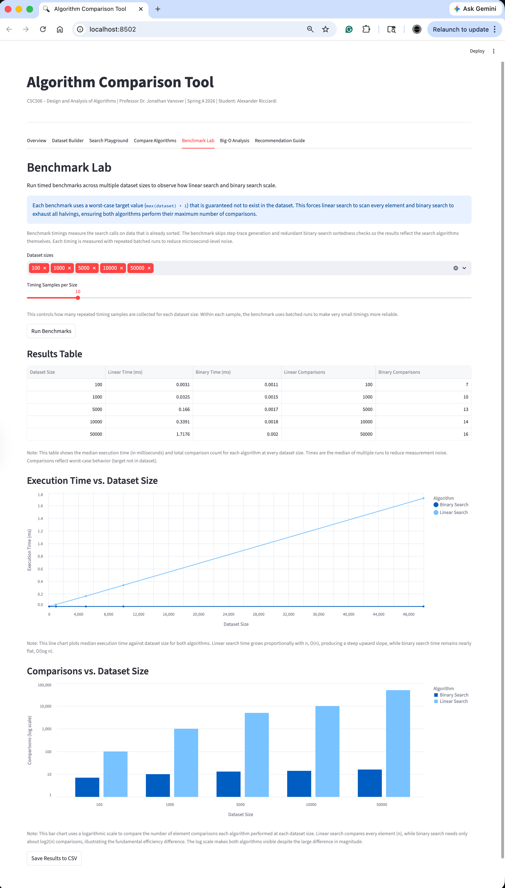
Big-O Analysis of Linear Search and Binary Search (see the provided Word Doc for the full text)
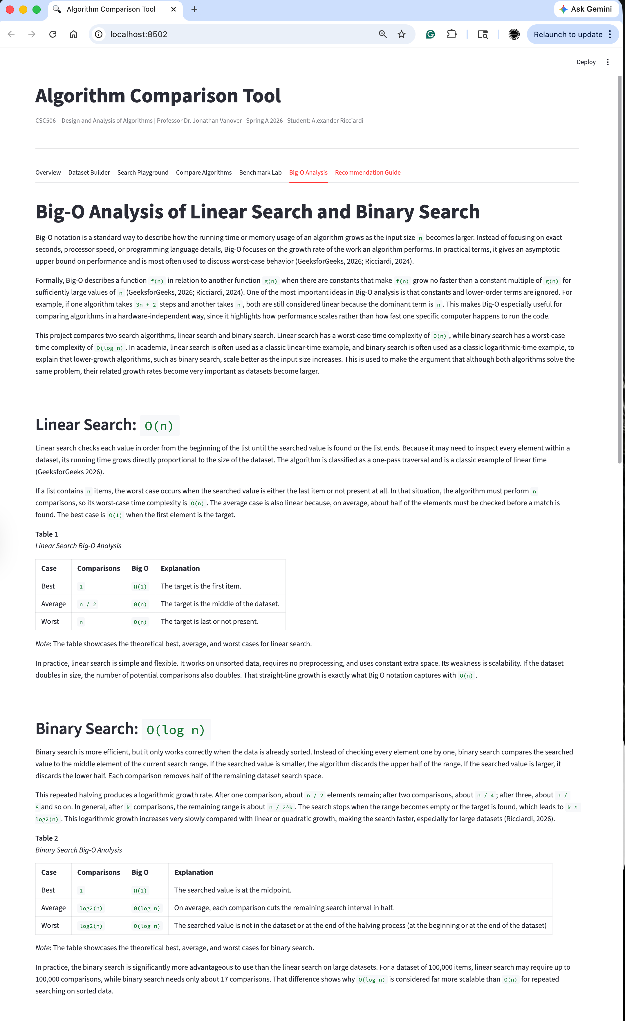
Recommendation Guide: When to Choose Each Search Algorithm (see the provided Word Doc for the full text)
